 | The Story of US! |  | Influencers |  | Don’t worry, Be Happy!
Driving Subjects | Humanities /ART/ PSHE |  | Humanities / DT |  | Expressive Arts & DT/ PSHE
 | Autumn 1 | Autumn 2 | Spring 1 | Spring 2 | Summer 1 | Summer 2
Nursery | A book about me!  Here I am!/Starting school | Someone at home book  My home/Story Homes | My book of people  People who help us/ Special people | A book about Animals/ A counting book  All creatures great and small | A book about Animals/ A counting book  Circus | Let’s make ABC books  Carnival
Reception | ‘Things I like’  A book about me!  Marvellous Me! | Once upon a time books.  Let’s explore! | Pattern Books  I wish books  Superheroes | Information books  Super Space | A book about a place  Holidays | Let’s make ABC books  Carnival
Year 1 | ‘Hair Love’ by Mathew A Cherry  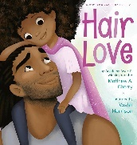  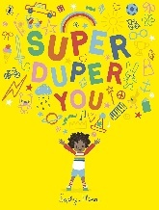  ‘Super Duper You’ by Sophie Hen  ‘What makes me a me?’ by Ben Faulks and David Tazzyman  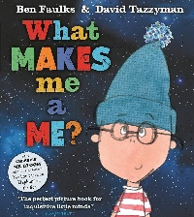 | ‘Supertato’ books  By Sue Hendra and Paul Linnet  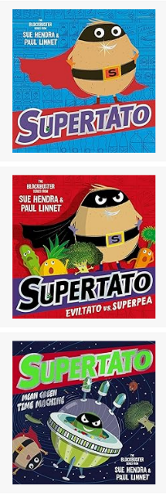  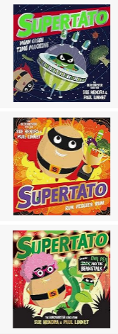 | ‘Martha Maps it out’  by Leigh Hodgkinson  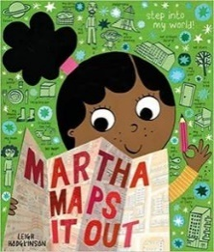 | ‘Rocket’ series, by Nathan Bryon  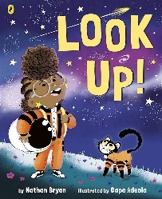  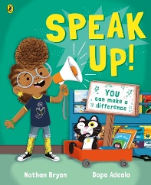  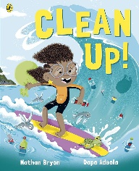 | ‘Wanted: The Perfect Pet’ by Fiona Roberton  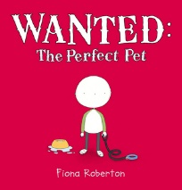 | l
OUTCOMES | What makes you you?  Simple books about themselves | Own ‘Supertato’ adventure story | https://www.  picturebooksnob.  com/post/  martha-maps-it-out  Link with Geography |  | Research different pets  Perfect pet advert  Own story with perfect pet
Year 2 | ‘Beegu’ by Alexis Deacon  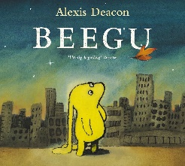 |  | ‘If I were Priminister’ by Trygve Skaug  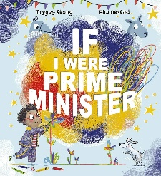  ‘What We’ll Build’ by Oliver Jeffs  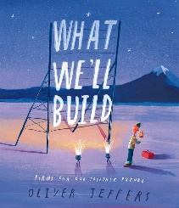 |  | ‘Ada Twist Scientist’, ‘Rosie Revere, Engineer’, ‘Sofia Valdez, Future Prez’  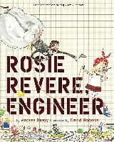  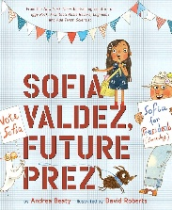  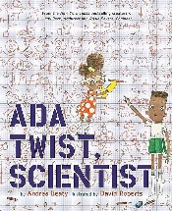  By Andrea Beaty
OUTCOMES | Lost poster  Letter writing  Diary entry  Character description |  | What will the future look like?  What would you do if you were Prime Minister? |  | When I grow up…
Year 3 | ‘Clever Polly and the Stupid Wolf’ series by Catherine Starr.  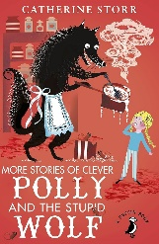  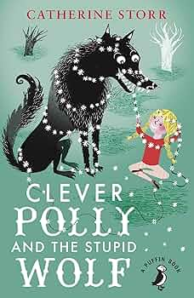 |  | 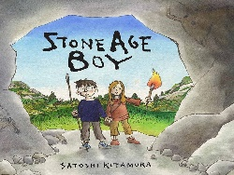  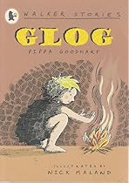  ‘Stone Age Boy’ by Satoshi Kitamura  ‘Glog’ by Pippa Goodheart | Information text | ‘My name is not refugee’ by Kate Milner  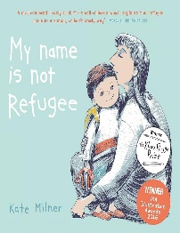
OUTCOMES | Alternative Fairy Tales  Further adventures of Clever Polly |  | Diary  Information text  Guide to the Stone Age | A guide to The Stone Age | Refugee wk ~ June  Diary entries  Letters  Writing in role
Year 4 | ‘Stitch Head’ by Guy Bass  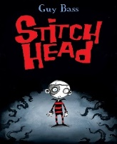  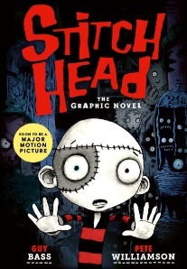 | Biographies | ‘The Barnabus Project’ by The Fan Brothers  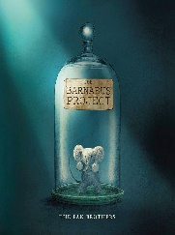 |  | 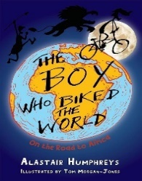  ‘The Boy Who biked Around the World- Part 1’ by Alastair Humphreys
OUTCOMES | Monster reports (information text)  Persuasive speech | Someone I know / admire | Explanation texts  A Guide to …  Diary entries |  | Character and setting descriptions  Adventure story
Year 5 | 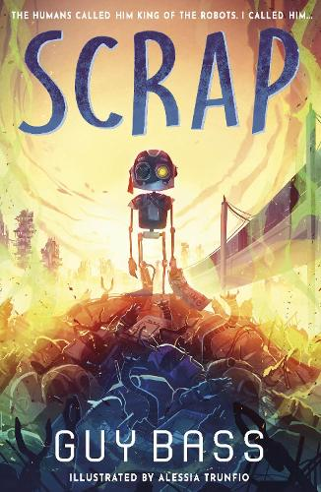  ‘Scrap’ by Guy Bass | Opinion and persuasive writing | All the things that could go wrong’ by Stewart Foster  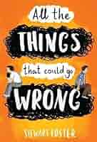 | Graphic Novels | ‘Zombierella’  Twisted Fairy tales  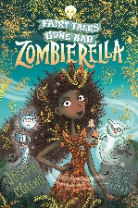  ‘Creeping Beauty’ Joseph Coelho  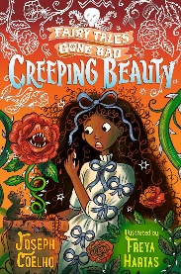 | Memoirs
OUTCOMES | Discussions about the future of humanity/ the climate/technology  Science fiction short stories with a flasback | Letter to persuade (real purpose) | Writing in role  Diary and letter writing  Discussion ~ bullies and Bullying | Character and setting descriptions | Own twisted fairy tale book / graphic novel
Year 6 | Autobiographies  Looking forwards and back in our lives | ‘Skellig’ by David Almond  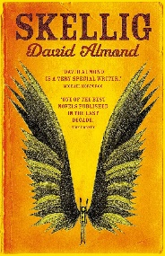 | ‘Illegal’ by Eoin Colfer  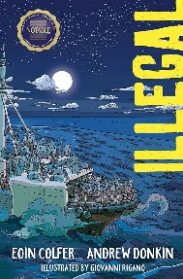 | ‘It’s an AI world  Explanation | ‘The Final Year’  Memories of Bond
Year 6 | ‘Cicada’ by Shaun Tan  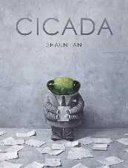 |  |  | ‘The Final Year’ by Matt Goodfellow  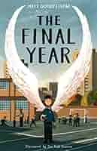
OUTCOMES | Writing in role | Building suspense in a chapter  Descriptive writing (character and setting) | Descriptive writing  Writing in role | Writing in role  Poetry
OUTCOMES | Letters of complaint |  | Discussions about refugees and migrants | Writing in role  Poetry

