 | Computing systems and networks | Creating media A  Bond Primary school: Progression skills | Programming A | Data and information | Creating media B | Programming B
Year 1 | Computing around us  To choose a piece of technology to do a job  To recognise that some technology can be used in different ways.  To identify the main parts of a computer  To use a mouse in different ways.  To use a keyboard to type.  To show how to use technology safely. | Digital painting  To create a picture using freehand tools.  To use shape and line tools when precision is needed.  To use a range of paint colours.  To use the fill tool to colour an enclosed area.  To use the undo button to correct a mistake.  To combine a range of tools to create a piece of artwork. | Moving a robot  To predict the outcome of a command on a device.  To list which commands can be used on a given device.  To run a command on a floor robot.  To choose a command for a given purpose.  To choose a series of words that can be enacted as a program.  To choose a series of commands that can be run as a program.  To build a sequence of commands in steps and run a program. | Grouping data  To identify some attributes of an object.  To collect simple data.  To show that collected data can be counted.  To describe the properties of an object.  To choose an attribute to group objects by.  To group objects to answer questions.  To explain that objects can be grouped by similarities (attribute).  To describe a group of objects (based on commonality) | Digital writing  To use letter, number, and Space keys to enter text into a computer.  To use punctuation and special characters.  To select text  To use the Backspace key to remove text.  To position the text cursor in a chosen location.  To choose options to achieve a desired effect.  To change the appearance of text on a computer. | Animations  (Scratch JR)  To choose a series of words that can be enacted as a program.  To choose a series of commands that can be run as a program.  To run a program on a device.
 | Computing systems and networks | Creating media A | Programming A | Data and information | Creating media B | Programming B
Year 2 | IT around us  To describe some uses of computers.  To identify information technology in school.  To identify information technology beyond school.  To show how to use information technology safely. | Digital Photography  To capture a digital image.  To take photographs in both landscape and portrait format.  To view photographs on a digital device.  To hold the camera still to take a clear photograph.  To use zoom to change the composition of a photograph.  To consider lighting before taking a photograph.  o improve a photograph by retaking it  To use filters to edit the appearance of a photograph. | Robot algorithm  To choose a series of words that can be enacted as a sequence.  To choose a series of instructions that can be run as a program.  To create a program  To run a program on a device  To trace a sequence to make a prediction  To debug a program that I have written. | Pictograms  To show I can enter data onto a computer  To use a computer to view data in different formats.  To use pictograms to answer single-attribute questions.  To use a computer to answer comparison questions (graphs, tables). | Digital music  To experiment with musical patterns on a computer.  To experiment with different sounds on a computer.  To use a computer to create a musical pattern.  To use a computer to compose a rhythm and a melody on a given theme.  To use a computer to play the same music in different ways (e.g. tempo).  To evaluate a musical composition created on a computer.  To improve a musical composition created on a computer. | Programming quizzes  To choose a series of words that can be enacted as a sequence.  To explain what happens when we change the order of instructions.  To choose a series of commands that can be run as a program.  To create and debug a program that I have written.  To run a program on a device.
 | Computing systems and networks | Creating media A | Programming A | Data and information | Creating media B | Programming B
Year 3 | Connecting computers  To identify input and output devices.  To explore that a computer system accepts an input and processes it to produces an output.  To explain how a computer network can be used to share information.  To explain the role of a switch, server and wireless access point in a network.  To identify network devices around me.  To explain how networks can be connected to other networks. | Stop frame animation  To plan an animation using a storyboard.  To set up the work area with an awareness of what will be captured.  To capture an image.  To use the oninon skinning tool to review subject position.  To move a subject between captures.  To review a captured sequence of frames as an animation.  To remove frames to improve an animation. | Sequencing sounds  To build a sequence of commands.  To combine commands in a program.  To order commands in a program.  To create a sequence of commands to produce a given outcome. | Branching databases  To create questions with yes/no answers  To choose questions that will divide objects into evenly sized subgroups.  To repeatedly create subgroups of objects.  To identify an object using a branching database.  To retrieve information from different levels of the branching database. | Desktop publishing  To show that page orientation can be changed.  To organise text and image placeholders in a page layout.  To add and edit text to a placeholder.  To add and remove images to and from placeholders.  To move resize and rotate images.  To choose fonts and apply effects to text.  To review a document. | Events and actions in programs (Scratch)  To build a sequence of commands.  To combine commands in a program.  To order commands in a program.  To create a sequence of commands to produce a given outcome.
 | Computing systems and networks | Creating media A | Programming A | Data and information | Creating media B | Programming B
Year 4 | The internet  (Concepts are taught in this unit not skills) | Audio Production  To record sound using a computer.  To play recorded audio.  To import audio into a project.  To delete a section of audio.  To change the volume of tracks in a project. | Repetition of shapes  To list an everyday task as a set of instructions including repetition.  To use an indefinite loop to produce a given outcome.  To use a count-controlled loop to produce a given outcome.  To plan a program that includes appropriate loops to produce a given outcome.  To recognise tools that enable more than one process to be run at the same time (concurrency).  To create two or more sequences that run at the same time. | Data logging  To use a digital device to collect data automatically.  To choose how often to automatically collect data samples.  To use a set of logged data to find information.  To use a computer program to sort data by one attribute.  To export information in different formats. | Photo editing  To recognise that digital images can be manipulated.  To recognise that digital images can be changed for different purposes.  To choose the most appropriate tool for a particular purpose.  o consider the impact of changes made on the quality of the image. | Repetition in games  To list an everyday task as a set of instructions including repetition.  To use an indefinite loop to produce a given outcome.  To use a count-controlled loop to produce a given outcome.  To plan a program that includes appropriate loops to produce a given outcome.  To recognise tools that enable more than one process to be run at the same time.
Year 5 | Systems and searching  To describe the input and output of a search engine.  To demonstrate that different search terms produce different results.  To evaluate the results of search terms. | Video production  To use different camera angles.  To use pan, tilt and zoom.  To identify features of a video recording device or application.  To combine filming techniques for a given purpose.  To determine what scenes will convey your idea.  To decide what changes I will make when editing.  To use split, trim and crop to edit a video. | Physical computing  To create a condition-controlled loop.  To use a condition in an ‘if...then...’ statement to start an action.  To use selection to switch the program flow in one of two ways.  To use a condition in an ‘if...then...else...’ statement to produce given outcomes. | Flat file databases  To choose different ways to view data.  To choose which attribute and value to search by to answer a given question (operands).  To ask questions that need more than one attribute to answer.  To choose which attribute to sort data by to answer a given question.  To choose multiple criteria to search data to answer a given question (AND and OR).  To select an appropriate graph to visually compare data.  To choose suitable ways to present information to other people | Vector graphics  To add an object to a vector drawing.  To select one object or multiple objects.  To delete objects.  To move objects between the layers of a drawing.  To group and ungroup selected objects.  To duplicate objects using copy and paste.  To modify and reposition objects.  To combine options to achieve a desired effect.  To create a vector drawing for a given purpose. | Selection in quizzes  To choose a condition to use in a program.  To create a condition-controlled loop.  To use a condition in an ‘if... then...’ statement to start an action.  To use selection to switch program flow.  To use ‘if... then... else...’ to switch program flow in one of two ways.
 | Computing systems and networks | Creating media A | Programming A | Data and information | Creating media B | Programming B
Year 6 | Communication and collaboration.  To outline methods of communicating and collaborating using the internet.  To choose methods of internet communication and collaboration for given purposes.  To evaluate different methods of online communication and collaboration.  To decide what you should and should not share online. | Webpage creation  To review an existing website (navigation bars, header).  To create a new blank web page.  To add text to a web page.  To set the style of text on a web page.  To embed media in a web page.  To add web pages to a website.  To insert hyperlinks between pages.  To insert hyperlinks to another site.  To preview a web page (different screen sizes). | Variables in games  To identify a variable in an existing program.  To experiment with the value of an existing variable.  To choose a name that identifies the role of a variable to make it easier for humans to understand it.  To decide where in a program to set a variable.  To update a variable with a user input.  To use an event in a program to update a variable.  To use a variable in a conditional statement to control the flow of a program. | Introduction to speadsheets  To calculate data using a formula for each operation.  To use functions to create new data.  To use existing cells within a formula.  To choose suitable ways to present spreadsheet data. | 3D Modelling  To position 3D shapes relative to one another.  To use digital tools to modify 3D objects.  To combine objects to create a 3D digital artefact.  To use digital tools to accurately size 3D objects.  To construct a 3D model which reflects a real world object. | Sensing movement  To identify a variable in an existing program.  To experiment with the value of an existing variable.  To choose a name that identifies the role of a variable to make it more usable (to humans).  To decide where in a program to set a variable.  To update a variable with a user input.  To use an event in a program to update a variable.  To use the same variable in more than one location in a program
Year 6 | Computing systems and networks | Creating media A | Programming A | Data and information | Creating media B | Programming B
EYFS do not follow Teach computing. However, through play and exploration the children are introduced to the uses of technology and observed using devices in their everyday experiences. Ie laptops, supermarket check out tills, cameras.
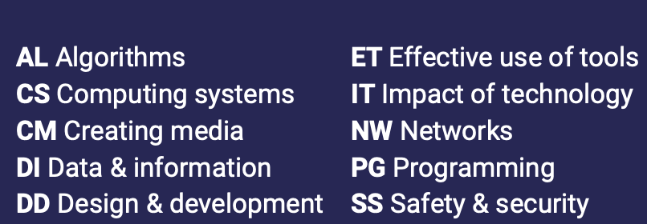

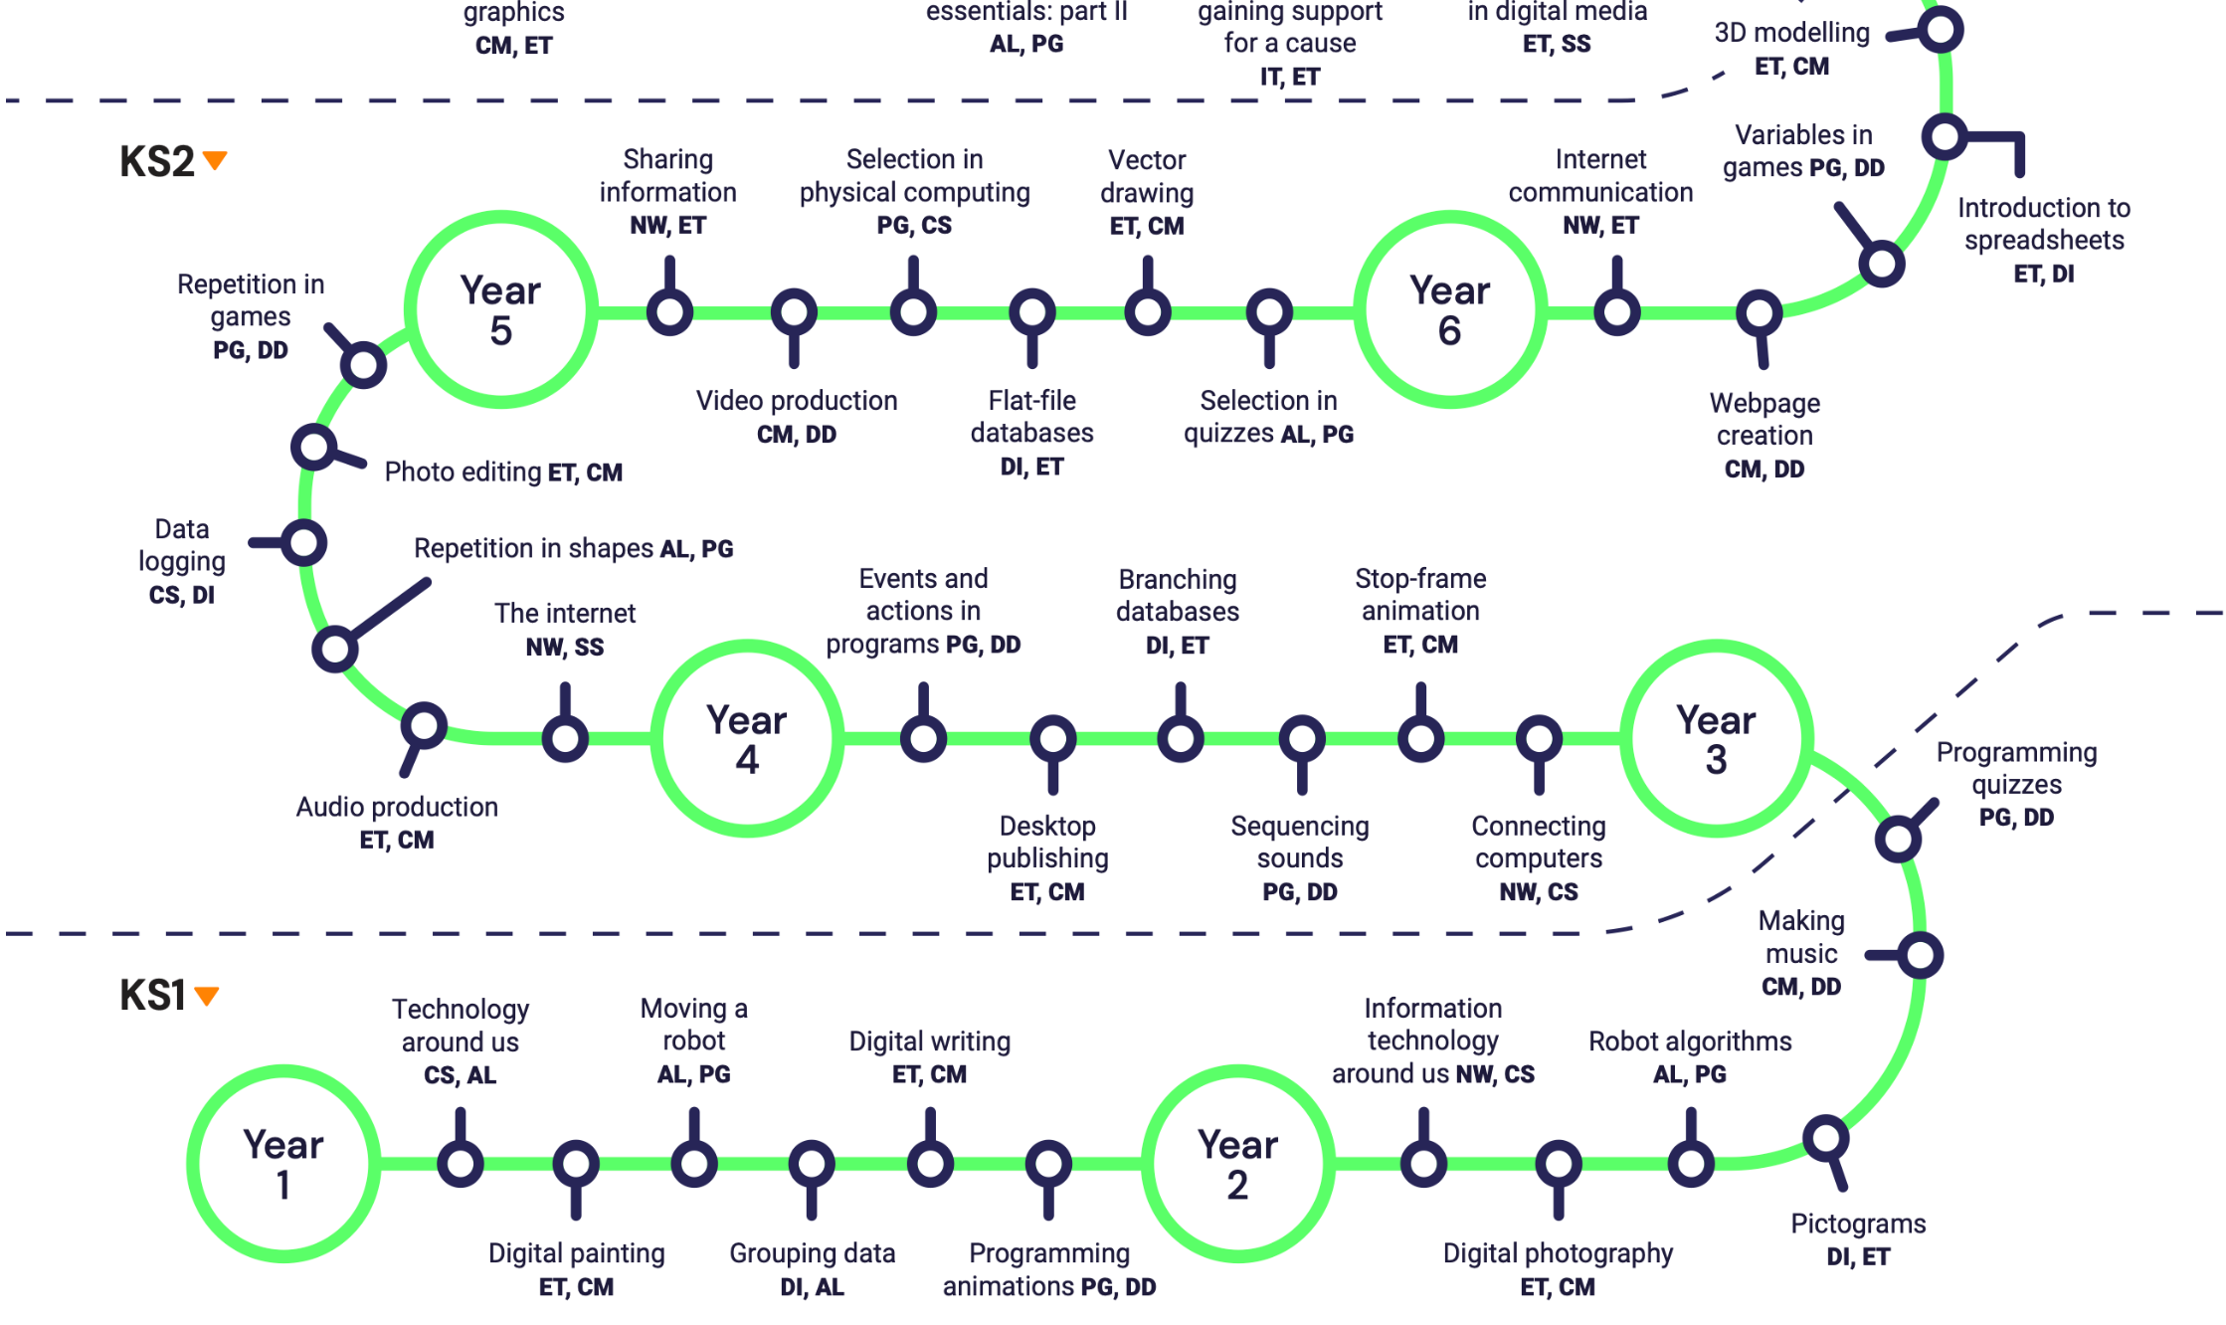

Bond Primary school
Progression of skills

