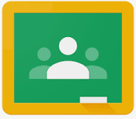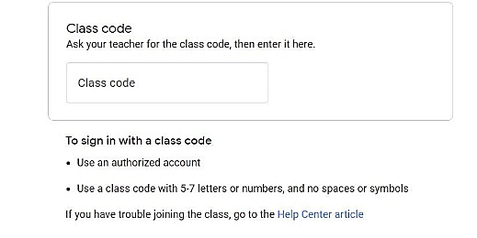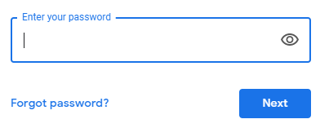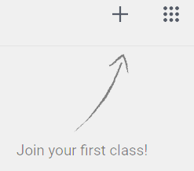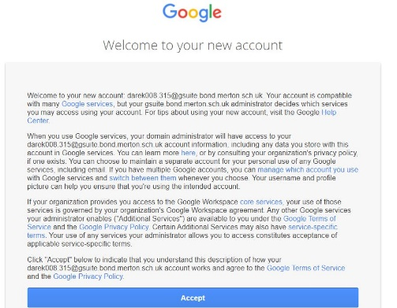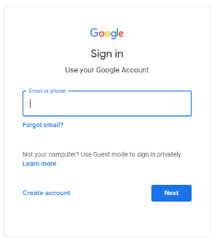



1. Download or search for Google classroom. It is a free app.

2) Sign in with **YOUR USERNAME** which your teacher gave you to the email below. It should look like this.

**username315@gsuite.bond.merton.sch.uk**

3) **Enter your password**

4) Welcome to your new account

**Click ‘Accept’**

7) *Enter the class code sent by your teachers on class dojo.*

*You should see your class name!*

**YOU’RE IN!**

5) *Welcome to your new account*

**Click ‘Continue’**

6) *Join class* is on the right in the corner

**Click ‘Continue’**

